Practical-5
Registration Form with Frontend Validation and User-Friendly Error Handling

Theory
- Are correct input types and attributes used?
Answer: Yes, suitable types like email, password, and date are used to make input easier and more accurate..

Are validation errors displayed near the relevant fields?
Answer: Yes, errors are shown near the field so the user can easily understand what needs to be corrected.

Is password strength checked?
Answer: Yes, the password is checked using rules like uppercase, lowercase, number, and special character.

Is the form accessible using keyboard and screen-reader-friendly labels?
Answer: Yes, proper <label> tags are used, and the form can be operated using the keyboard and understood by screen readers.

Result:

Evidence of Work (Screenshots)

Regex outputs:
  - login page
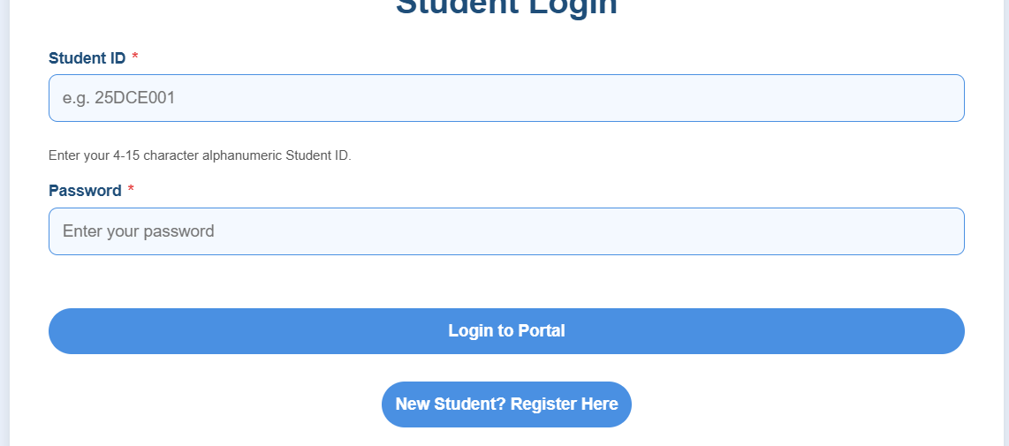

contact page
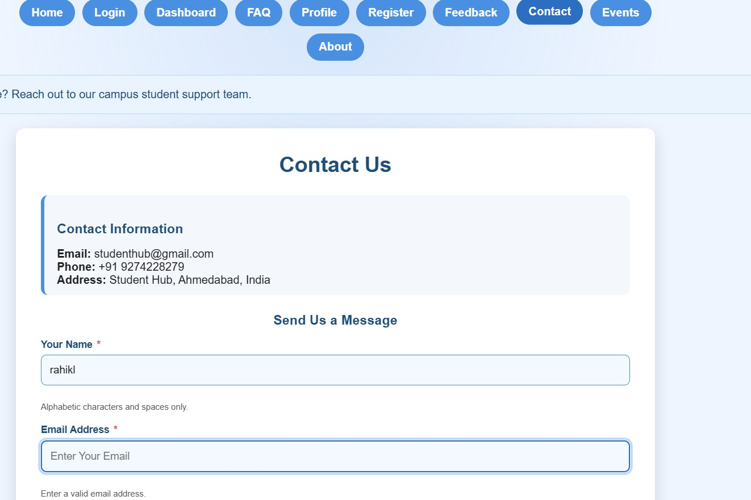

Register page
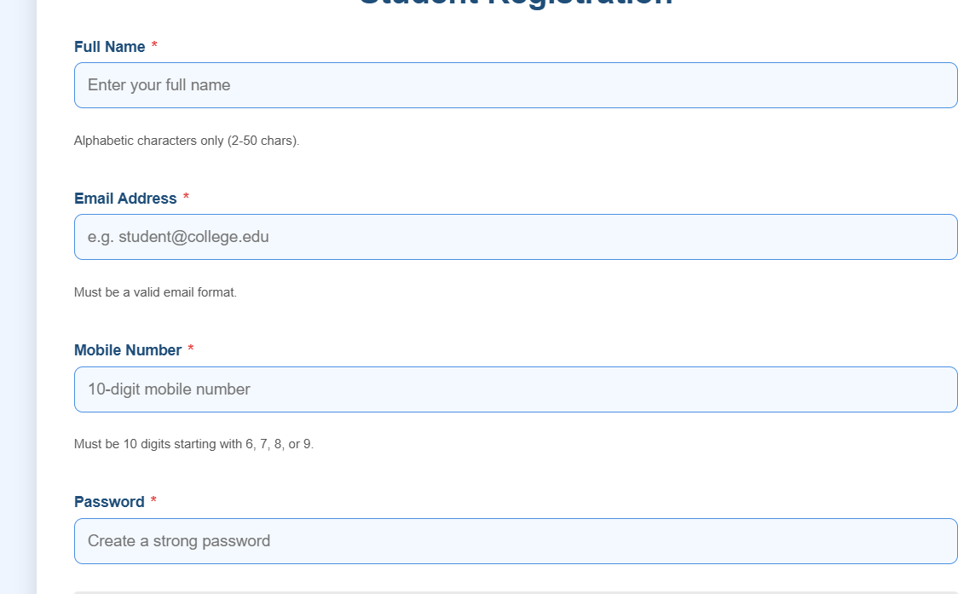

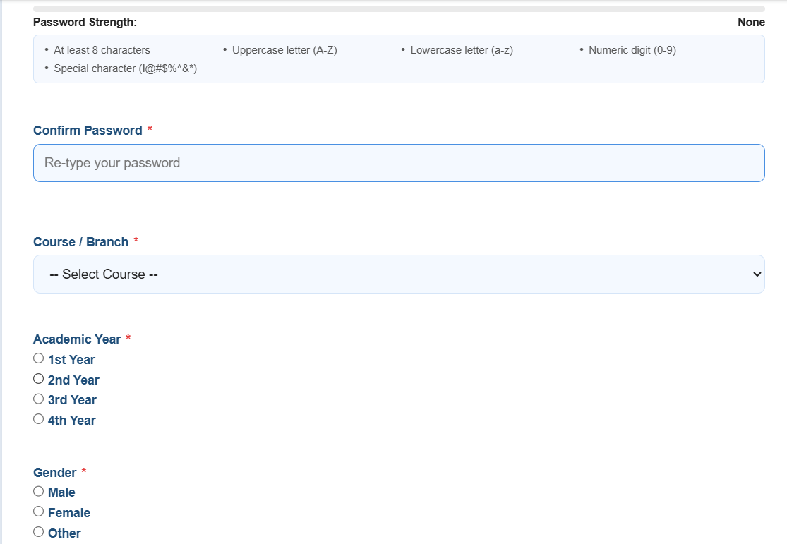

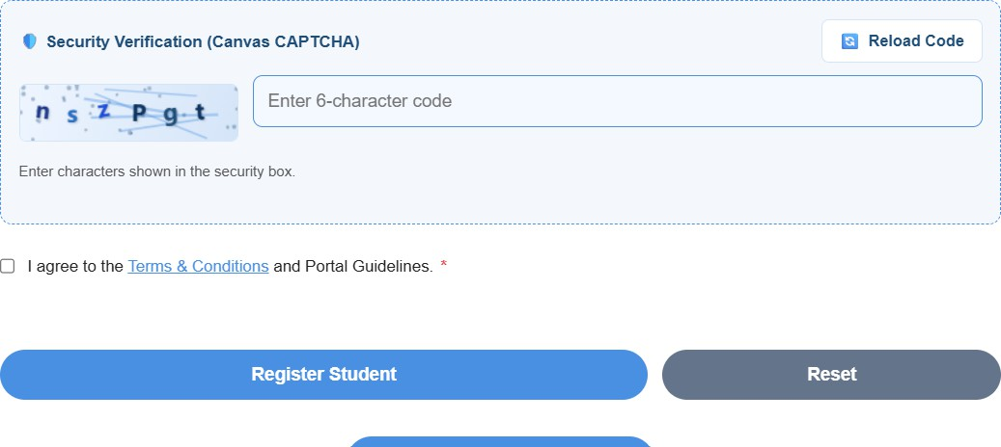

Event page

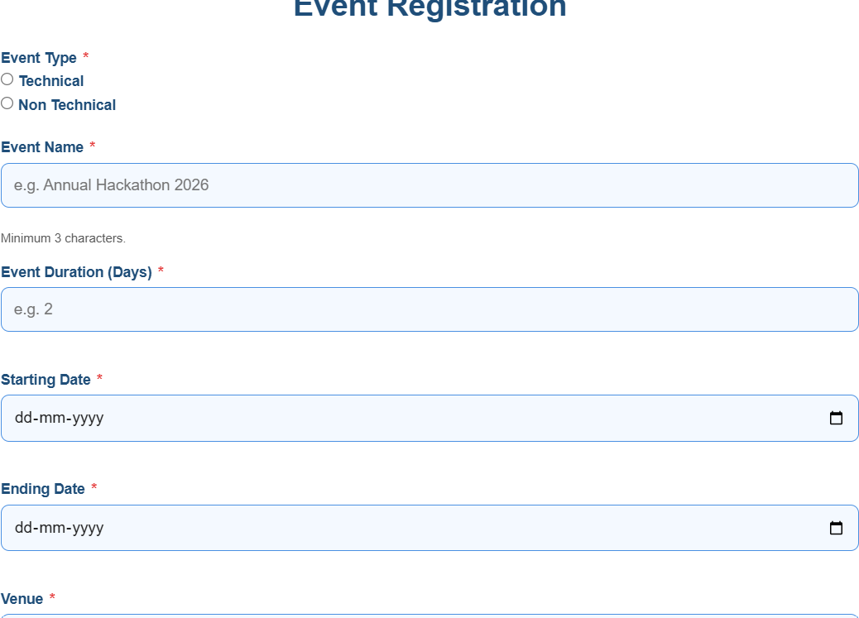

GitHub Repository Link:

https://github.com/RahilBarchha/student-hub-.git

Challenges Faced:
- Understanding how to select and modify HTML elements and how to apply java
- How to validate input using regex .
- How to connect Regex with field and html tage.
- How to Make Regex expression for diff-diff field value.

Learning Outcome:-
After This I’ll know How to Use Regex For Form validation or Anything Which is We Want to Validate Using Only one Expression.How To Map Javascript With html.

